# 

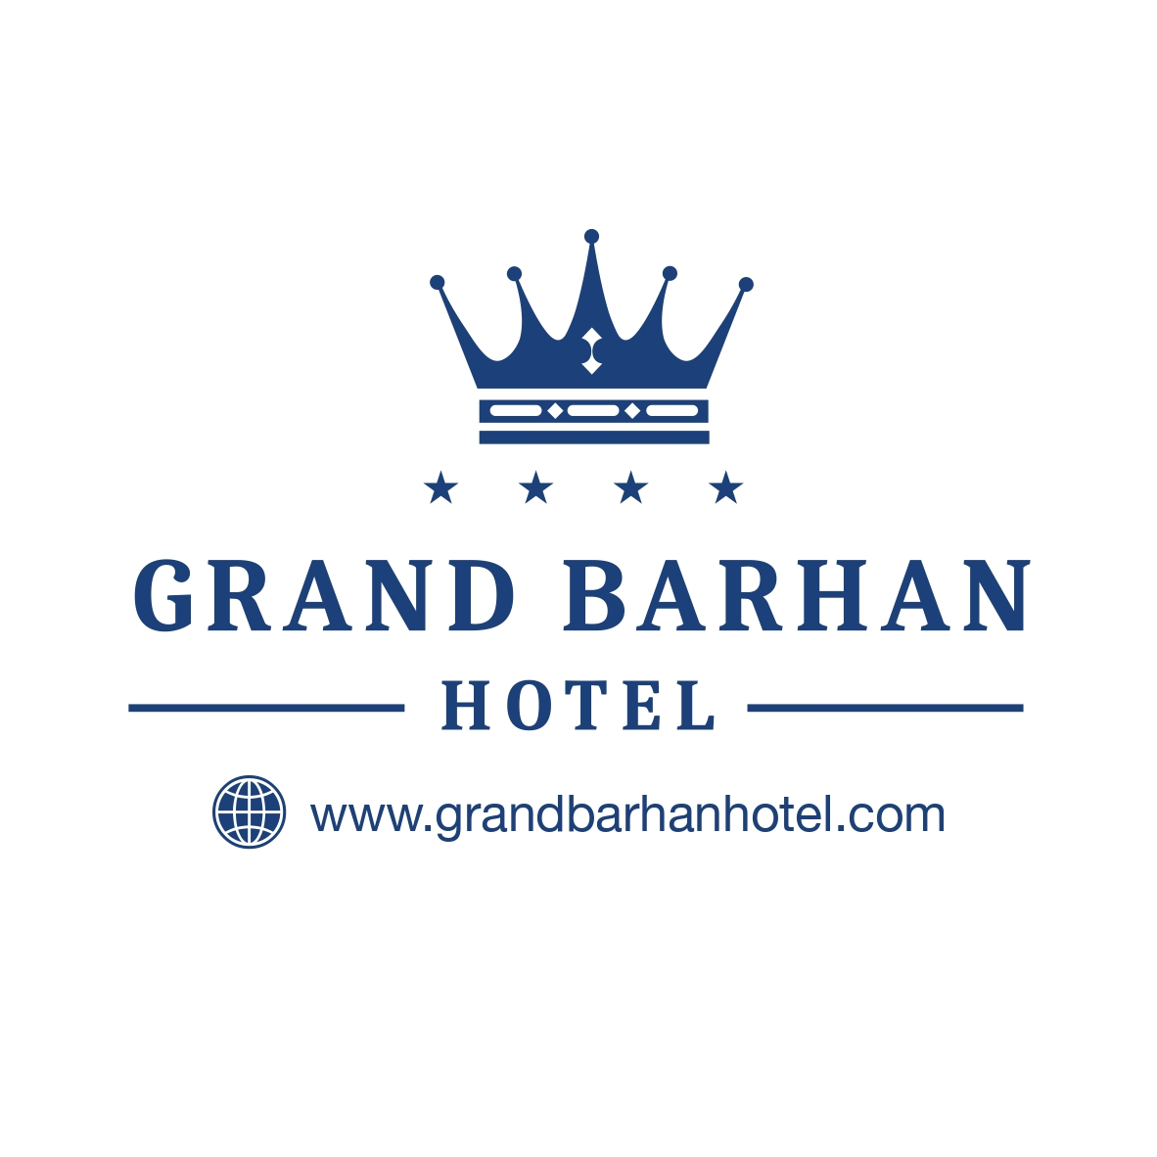

# 

# GRAND BARHAN HOTEL

# ALL INCLUSIVE CONCEPT

# SUMMER

**BREAKFAST** **:** **07,30-10,00** OPEN BUFFET ( REST)

**LUNCH** : **12,30-14,00** OPEN BUFFET (REST)

**OBSERVATION**  **:** **14,00-16,00** (BAR)

**CAFE TIME** **: 16,30-17,00** COFFEE,TEA AND CAKE ( BAR)

**DINNER** **:** **19,00-21,00** OPEN BUFFET ( REST)

NIGHT SOUP : 23,30 – 24,00

**BARS** **:** **10:30 – 23:00**

TEA, BEER, WINE, VOTKA, GIN, WATER, MINERALWATER, COKE, FANTA, SPRITE, CONCENTRADE FRUIT JUICE, SEVERAL COCKTAILS. ( ALL DRINKS SERVED BY GLAS)

**EXTRA’S :**

SAFE, WATER SPORTS, TELEPHONE, FRESH ORANGE JUICE, , IMPORT BEVERAGES, DOCTOR, LAUNDRY SERVICE.

WIFI: GENERAL AREA FREE, INTHE ROOM EXTRA.

**CHAISE-LOUNGE, SUN UMBRELLA, MATTRESS ARE FREE.**